Contact: | Sam Clark
Email: | sclark@hlbinsol.com.au
Phone: | (08) 9215 7955

25 May 2015

TO THE CREDITOR AS ADDRESSED

Dear Sir / Madam

Blundell Investments (2001) Pty Ltd (In Liquidation) ACN: 097 276 901
(“the Company”)

As you will be aware, I was appointed as the Liquidator of the above named Company on 10 March 2014 in accordance with a resolution passed by the members of the Company.

The liquidation is being administered as a creditors’ voluntary winding up under the provisions of the Corporations Act 2001 (“the Act”).

Annual obligations of liquidator – meeting or report (section 508)

The Act requires that where a voluntary winding up continues for more than one year, the Liquidator is required to convene annual general meetings of creditors to lay before the meeting an account of his acts and dealings and the conduct of winding up during the preceding year.

Alternatively, the Act provides that, in lieu of convening the meeting, the Liquidator may lodge a report with the Australian Securities & Investments Commission providing the same information, together with details of outstanding matters and an estimate of when the winding up will be finalised.

In this instance, I have opted to lodge a report with ASIC. A copy of my annual report is available from my office, free of charge, upon request.

If you have any queries, please liaise with the above contact.

Yours faithfully
Kim Wallman – Liquidator of
Blundell Investments (2001) Pty Ltd (In Liquidation) ACN: 097 276 901

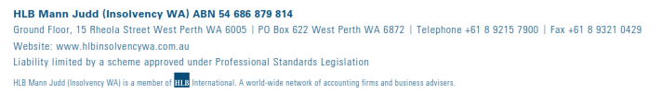
HLB Mann Judd (Insolvency WA) ABN 54 686 879 814
Ground Floor, 15 Rheola Street West Perth WA 6005 | PO Box 622 West Perth WA 6872 | Telephone +61 8 9215 7900 | Fax +61 8 9321 0429
Website: www.hlbinsolvencywa.com.au
Liability limited by a scheme approved under Professional Standards Legislation

HLB Mann Judd (Insolvency WA) is a member of International. A world-wide network of accounting firms and business advisers

